**LAB 6 TASKS**

**PRACTICE TASK 1:**

**CODE:**

#include<iostream>

using namespace std;

class entertainment

{

private:

string Title;

string Air_Date;

string* Genre;

string Type;

string Country;

string* Actors;

string Ratings;

int size1, size2;

public:

entertainment(int s1, int s2)

{

size1 = s1;

size2 = s2;

Genre = new string[size1];

Actors = new string[size2];

}

entertainment(const entertainment& other)

{

size1 = other.size1;

Genre = new string(*(other.Genre));

Country = other.Country;

Ratings = other.Ratings;

}

void set_data(string t, string a_d, string type, string c, string r)

{

Title = t;

Air_Date = a_d;

Type = type;

Country = c;

Ratings = r;

}

void set_genre(int index, string g)

{

if (index >= 0 && index < size1)

{

Genre[index] = g;

}

}

void set_actors(int index, string a)

{

if (index >= 0 && index < size2)

{

Actors[index] = a;

}

}

void display()

{

cout << " INFORMATION ABOUT THE DARAMA " << endl;

cout << " ------------------------------- " << endl;

cout << " Title : " << Title << endl;

cout << " Air date : " << Air_Date << endl;

cout << " Release Country : " << Country << endl;

cout << " Type : " << Type << endl;

cout << " Ratings : " << Ratings << endl;

cout << " Genre of darama : " << endl;

for (int i = 0;i < size1;i++)

{

cout << Genre[i] <<" "<< endl;

}

cout << " Actors of the darama : " << endl;

for (int i = 0;i < size2;i++)

{

cout << Actors[i] <<" "<<endl;

}

}

~entertainment()

{

delete[] Genre;

delete[] Actors;

}

};

void main()

{

entertainment obj1(3, 3);

obj1.set_data(" Entertainment ", " 10-oct-2022 ", " darama ", " pakistan ", " good ");

obj1.set_genre(0, " tragedy ");

obj1.set_genre(1, " mystery ");

obj1.set_genre(2, " melodarama ");

obj1.set_actors(0, " ahsan khan ");

obj1.set_actors(1, " saba kamar ");

obj1.set_actors(2, " ayesha malik ");

obj1.display();

entertainment obj2(obj1);

cout << endl;

cout << " -------------------------------------------" << endl;

cout << endl;

cout<<" output display when using the copy constructor : " << endl;

obj2.display();

}

**OUTPUT:**

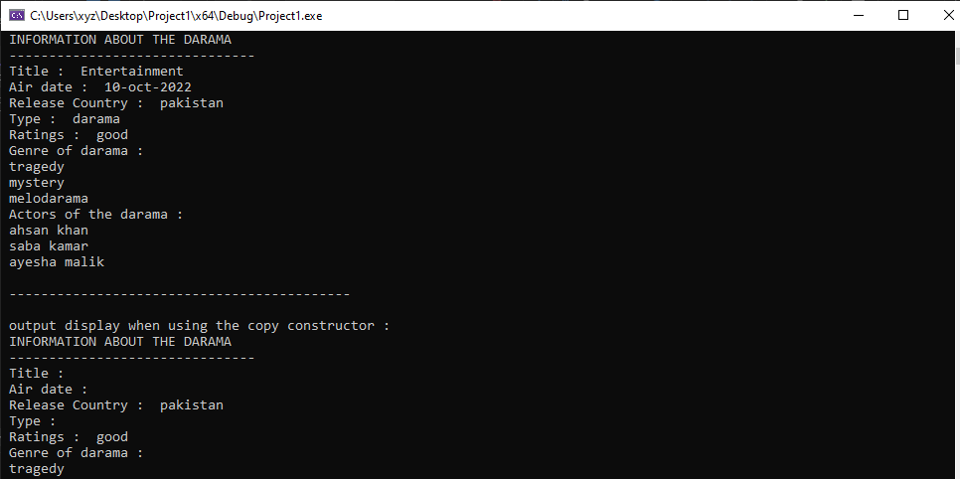

**PRACTICE TASK 2:**

**CODE:**

#include<iostream>

using namespace std;

class polygon

{

private:

int length;

int* width;

public:

polygon(int w, int l)

{

width = new int(w);

length = l;

}

polygon(const polygon& other)

{

width = other.width;

}

void set_data(int w, int l)

{

*width = w;

length = l;

}

void set_width(int w)

{

*width = w;

}

void display()

{

cout << " length of a polygon : " << length << endl;

cout << " width of a polygon : " << *width << endl;

}

};

void main()

{

polygon one(4, 5);

cout << endl;

cout << " first call to original object : " << endl;

cout << endl;

one.display(); // original object

polygon two(one);

cout << endl;

cout << " first call to copied object : " << endl;

cout << endl;

two.display(); // copy object

two.set_width(7);

cout << endl;

cout << " after modification of width from copied object : " << endl;

cout << endl;

two.display();

cout << endl;

cout << " and the data of original object : " << endl;

cout << endl;

one.display();

}

**OUTPUT:**

